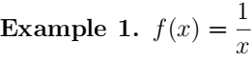
我们要求函数 f (x) = 的导数。为了求导，我们将会使用下面这个公式:
f, 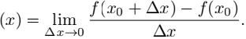
图像上, 我们将求出图像y = 上任意一点(x0 , ) 处的切线斜率。(函数y = 的图像是双曲线，正如函数 y = x2 的图像是抛物线)

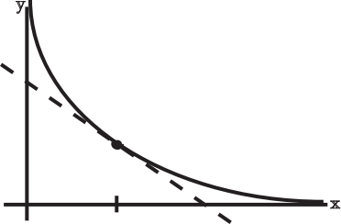
x0

Figure 1: Graph of
Fig 1: 的图像

我们首先计算割线的斜率:
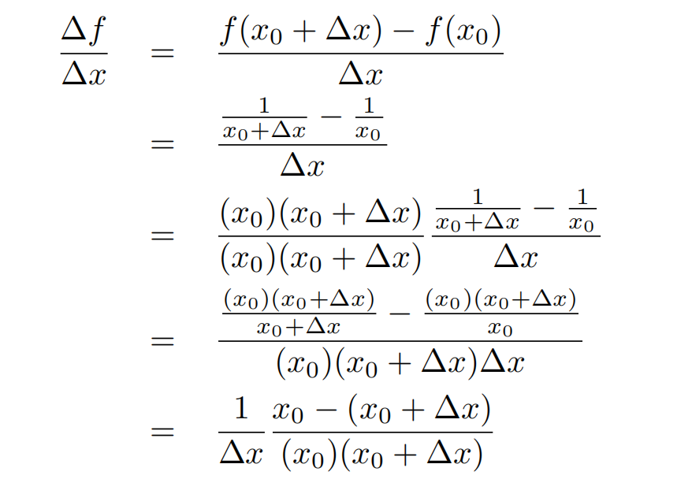

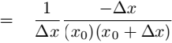
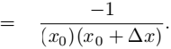

接下来，我们观察当Δx趋近于零时，割线的斜率会发生什么变化:
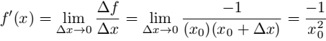
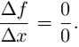
当计算导数时需要注意的一点: 人们可能很想直接带入Δx = 0 ，然而如果你直接这么做了，最后都会得出 你总是需要进行一些约简才能得到正确的答案。
我们计算得出 f 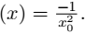 这正确吗？ 如何验证x₀的值?
首先， f (x0 ) 为负值 — 这与函数 y = 图像上切线的斜率一致。第二, 当 x0 → ∞ (即x₀趋近于无限大), 切线的斜率逐渐减小. 所以 随着x₀增大， 的值会趋近于 0 , 而实际结果也是这样的。
Question: 解释为什么 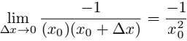 ?
Answer: x0 可以是任意一点; 我们可以设 x0 = 3 ，以特定情况求极限
We want to know the value of 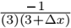 as Δ儿 tends toward zero. As Δ儿gets smaller and smaller 3 + Δ儿 gets closer and closer to 3, and so 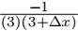 gets closer and closer to 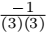 = .
Question: Why is it that 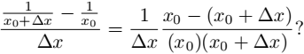
Answer: There are two steps in this simpliﬁcation. We factored out the Δ儿 that was in the denominator to become the “out front”. At the same time, we rewrote the diﬀerence of two fractions 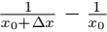 using a common denominator.
This common denominator was (儿0 )(儿0 + Δ儿), which is just the product of the denominators in 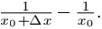 To get the common denominator, we multiply the ﬁrst fraction by 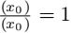 and the second by 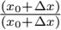 . (Multiplying by 1 won’t change its value, but can change the algebraic expression we use to describe that value.) The denominators cancel, as intended, and we’re left with 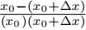 .

WIT OpenCourseWare
http://ocw.mit.edu

18.01SC Single Variable Calculus
Fall 2010

For information about citing these materials or our Terms of Use, visit: http://ocw.mit.edu/terms .

